Practical 8
Client–Server Communication Using ASP.NET Core MVC and Python Requests

Steps: -
- Open Microsoft Visual Studio 2019.
- Create a new project – ASP .NET Core Web Application / App (MVC)
- In Controllers folder create a new Controller Empty named HelloController and add the below code:
[HttpGet("{name}")]
public string GetHello(string name)
{
return $"Hello{name} from .NET";
}

- Now save and run the application and put a /name in the url
Example: https://localhost:44380/Ash
Output: -
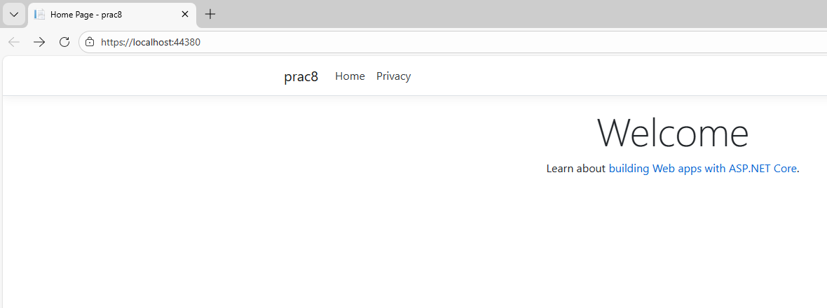
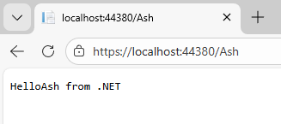
- In Command Prompt: python -m pip install requests
- Now Open Python IDE and create a file and write the below code:
import requests
url = "https://localhost:44380/Ash"
response = requests.get(url, verify = False)
print(response.text)

- Now save and Run the file.
Output: -
